**Automate an E-Commerce Web Application**

**Screenshots**

**Home Page:**



**Iphone 13 search:**

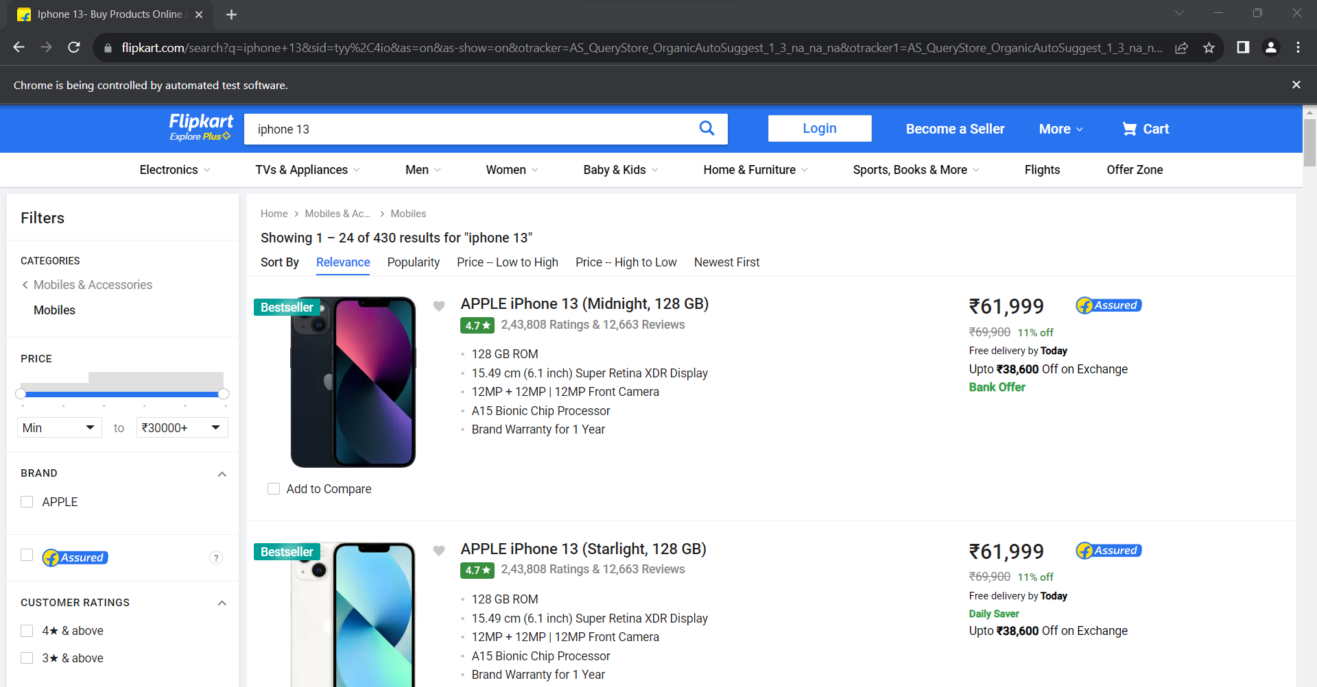

**Bottom page:**

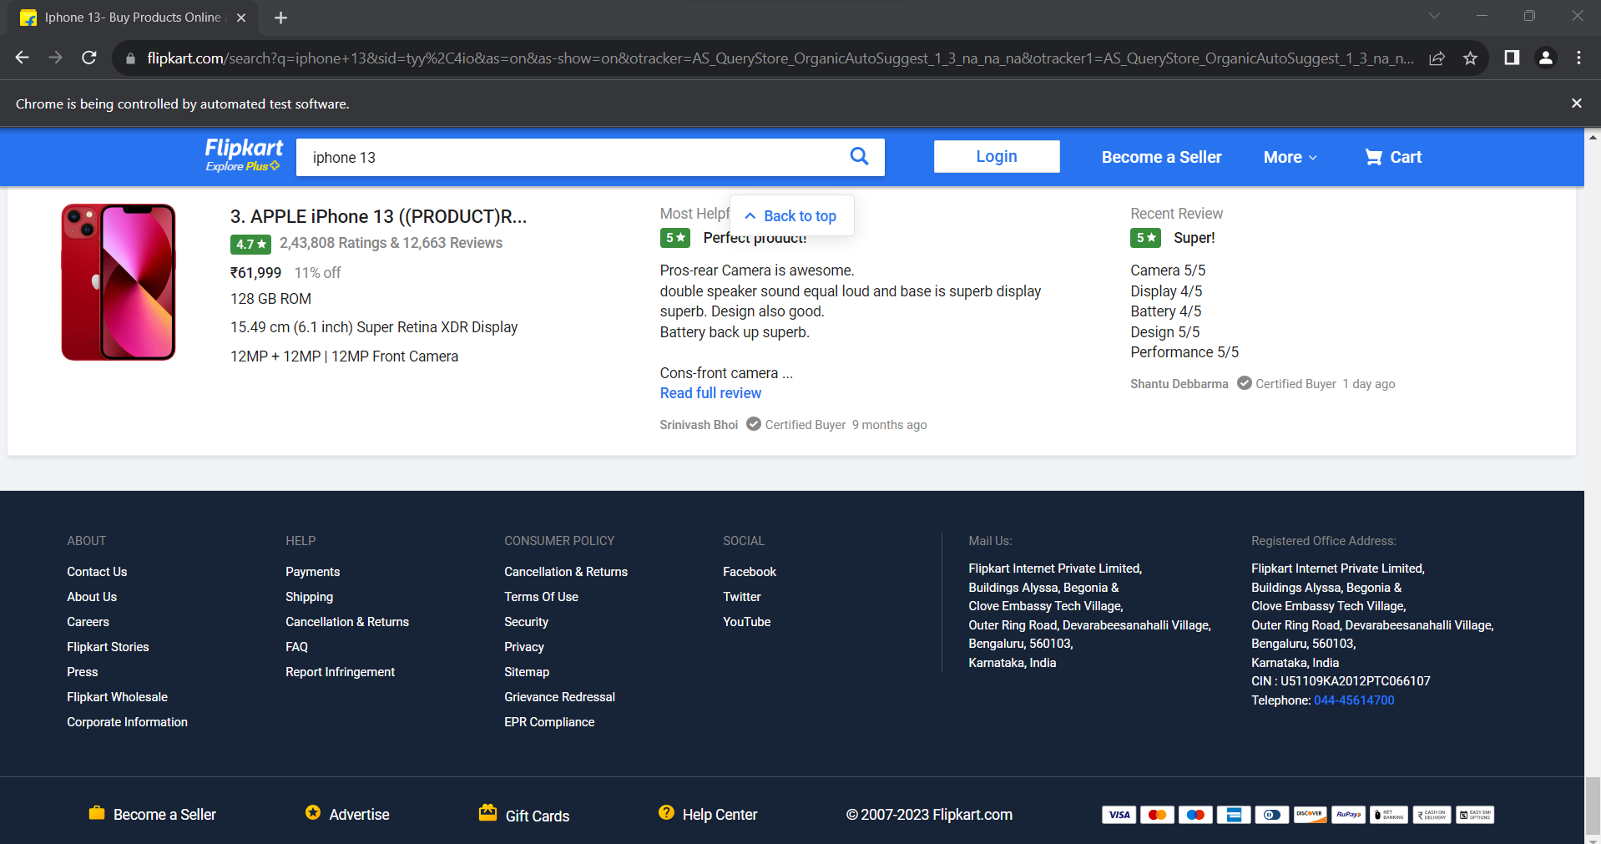

**Test cases:**

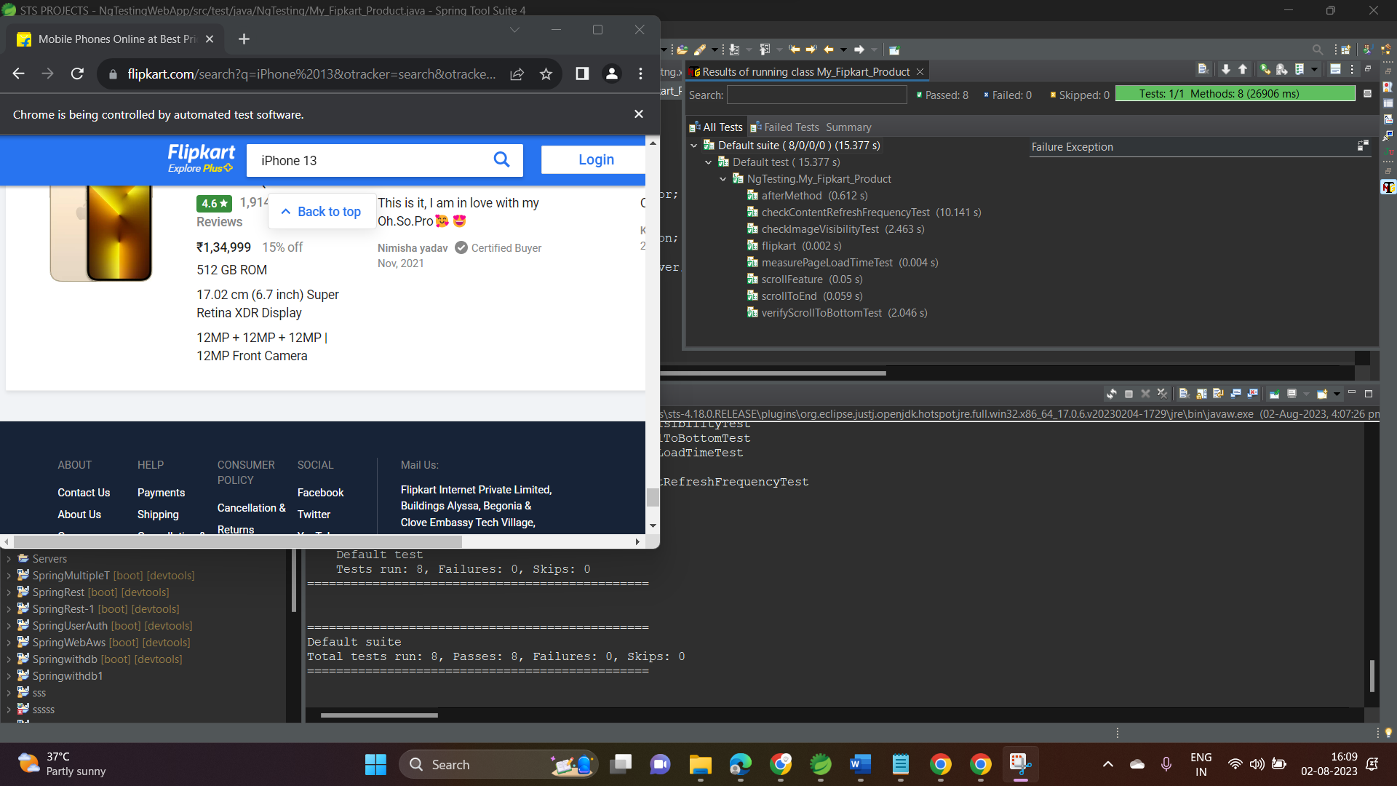

**Test Report:**

